
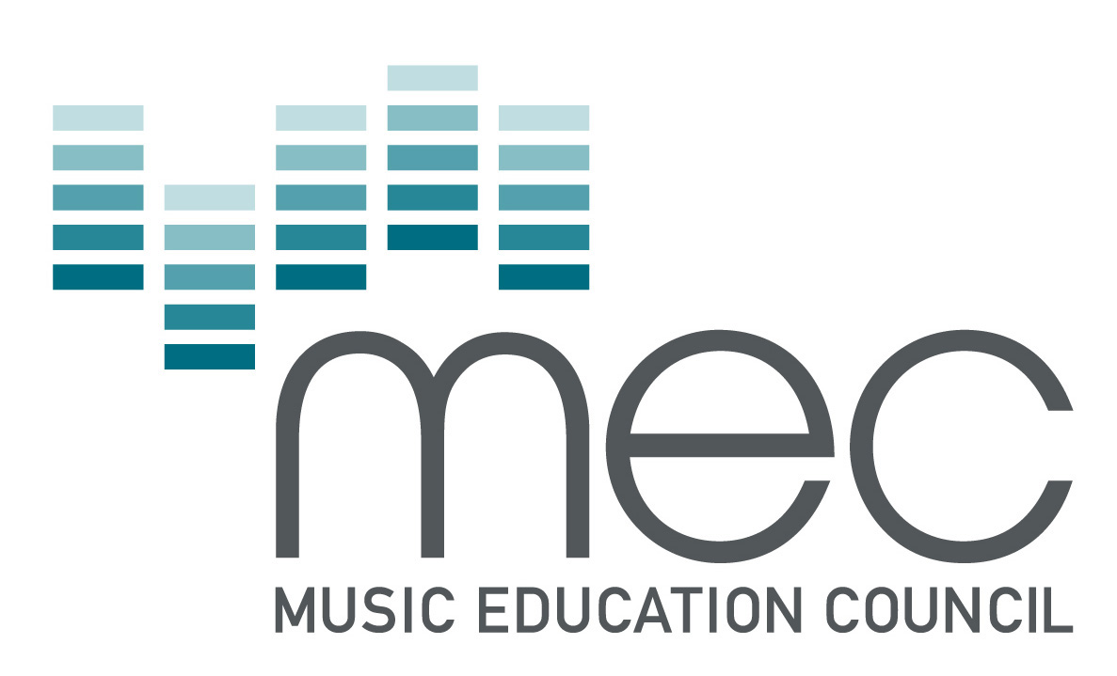

NATIONAL MUSIC COUNCIL
LOCAL EDUCATION AUTHORITY MUSIC AWARDS
FINANCIAL YEAR 2008/09

THE SCHEME: GUIDANCE NOTES FOR SCOTTISH AUTHORITIES:

These notes and the form itself should be read with the covering letter. If that letter has become detached, please contact Fiona Harvey by email or on one of the numbers set out at the end of the form.

Please read the whole form before answering the questions.

1. Please print and answer questions in summary as opposed to essay form.

2. Brief statements may be supplied expanding any of the numerical answers.

3. Please do NOT enclose photographs, programmes or publicity materials.

4 Include information for the financial year 2008/09 only.

5. Where a music service serves more than one Education Authority, it may be difficult to disaggregate the statistics, in which case approximate figures would be acceptable.

6. It is most important to include statistical evidence where it is available and to demonstrate impact where appropriate.

7. The submissions made will be considered by the National Music Council’s Awards Panel. The Panel's decision will be final and communicated to all submitting authorities at the earliest opportunity.

8. In the interests of spreading good practice and drawing attention to praiseworthy innovation, the NMC will continue to quote from submissions in its public annual report and on other appropriate occasions.

9. If you have not previously participated in this Scheme, you may find it helpful to refer to the five past exemplar submissions which appear on the Federation of Music Services (FMS) website (www.federationmusic.org.uk )

- Creative Music-Making – The PRSF is looking for a commitment to new music and composition across the range of activities of music services. In awarding its Diplomas PRSF will be looking for evidence to this effect through your submission. Please ensure that you have included information where relevant (initiatives, partnerships, teacher training, ICT provision etc.), that enables PRSF to assess this.

11. Jazz Services will again be looking for evidence of a commitment to jazz education on the basis of responses to the questions in the Appendix.

BACKGROUND DETAILS:

Date:

Name of Education Authority:

Overall population of authority area: school population:

Address:

Telephone: Fax: email:

Name of music service:

Address:

Telephone: Fax: email:

Contact details for queries:

FUNDING

- Please provide a brief summary and figures of how the Authority spent for the benefit of music education
a) Education Authority funds in 2008/09;
b) YMI funds to achieve the P6 Target;
c) Other funds from public sources;
d) Funds from other sources, including lottery funding.

ABOUT PROVISION (where appropriate, please state whether there has been a year on year increase or reduction in numbers):

- Please identify and describe any especially interesting features/highlights of the Authority’s 2008/09 music year, including
i) new initiatives
ii) previously successful programmes and projects which have been developed or consolidated

- Please list, by number in each category, music advisers; instrumental teachers/tutors, including peripatetic specialists teaching whole-class music; advisory teachers employed during 2008/09.

- Please describe all provision designed to provide whole class instrumental and vocal tuition, ie projects funded through the YMI;

a) percentage of schools involved;

    - new developments including where appropriate
the number of ‘new projects’ this year
- How is the work of the Music Service and the school curriculum integrated?

- Please identify and describe any music technology developments initiated by the Music Service.

- Please describe any steps taken by the Music Service to both involve and keep parents/carers informed in the tuition process.

- Please describe the range and scope of the INVOLVEMENT OF PROFESSIONAL MUSICIANS and other PERFORMING ARTS PRACTITIONERS from outside the education authority/Music Service in schools in 2008/09

- Please list examples of COLLABORATIONS and PARTNERSHIPS during the year with:

a. other education authorities/Music Services; eg shared training, reciprocal visits
b. national music organizations, eg FMS/HITS, NAME/SAME, MEC,
c. local arts and community organisations;
d. professional orchestras/ensembles
e. Arts Council (or nearest equivalent) offices;
g. any others.

  - Please describe any special arrangements made for the involvement in music activities of PUPILS/STUDENTS WITH DISABILITIES/SPECIAL EDUCATIONAL NEEDS during the year.
  - How effective is the provision for gifted & talented students, and in what ways are talented students nurtured?

- Please describe any provision for ADULTS in music activities during the year as part, for example, of the adult continuing education service. Please include work with other partners, such as community music groups and orchestras.

TRAINING & CPD

- Please describe the range and scope of

- In-service/in-house training programmes for music education provided by the Education Authority during the year, with the number of teacher-day attendances;

- other continuing CPD opportunities provided for instrumental tutors, with percentage of those from your Service able to attend, eg regional, national, international conferences.

NB It would be helpful if you could indicate where training was specific to YMI projects.

INSTRUMENTAL & VOCAL TUITION (where appropriate, please state whether there has been a year on year increase or reduction in number of staff employed and extent of uptake):

13. Please describe the range and scope of provision in schools by listing:

a. the number and type of instruments provided for school pupils to play;
b. those instruments for which tuition is provided, and the number of tutors;
c. the range of vocal work

14. Please describe the Authority’s policy in regard to charges for instrumental or vocal tuition.

- Please describe the range and scope of opportunities provided during the year (covering all sizes of groups and genre) for:

- regular (eg weekly) ensemble/workshop activity
b) group instrumental and vocal performance
c) out-of-school hours playing, eg regular Saturday activities, holiday course, participation in regional/national/international festivals or activities.

CREATIVE MUSIC MAKING

- The PRS Foundation is looking for evidence of commitment to new music and composition across the range of activities of music services. Rather than reiterate information you have already given, please refer back by number to the sections above where you feel this commitment is evident.
If there is any evidence you would like to be considered which has not been addressed by the scope of the form so far, please include it here.

APPENDIX

Jazz Education

Jazz Services Ltd (which body exists to promote and develop jazz in the UK) is looking for evidence of commitment to jazz education within Education Authority and Music Service provision for schools, community education and adult continuing education. Set out below are examples of criteria (not all of which would need to be met) to which the Awards Panel and Jazz Services will have regard when considering submissions:

a) qualifications (eg professional jazz musicians, specialist instrumental tutors) of tutors employed by the music service or directly by schools;
b) provision made within INSET and/or CPD for non-specialist teachers/tutors to develop a measure of jazz education expertise, eg workshops, guidance materials;
c) number, size and frequency of coming together of jazz ensembles supported by the education authority music service and individual schools;
d) provision of practical curriculum guidance, eg schemes of work, teacher notes;
e) availability of teaching of jazz arranging and/or composition;
f) opportunities for pupils and students to hear performances of live jazz; and to study recordings, including via CD, DVD, tape, video;
g) featuring of jazz in music and/or arts festivals promoted by the education authority
h) to the extent that recording of student performance is scheduled for assessment purposes, inclusion of jazz;
i) commissioning of original works of jazz for performance by young people or any ensemble supported or organised by the music service;
j) joint working with local jazz venues and promoters for performance, workshop or master class purposes.

PLEASE RETURN THIS FORM TO THE ADMINISTRATOR
BY EMAIL: info@nationalmusiccouncil.org.uk or
BY FAX : 0870 706 5329 or
BY POST: to Fiona Harvey, Administrator, National Music Council,
60/62 Clapham Road, London, SW9 0JJ
If you have any queries, please telephone Fiona Harvey on: 020 7422 8297 or mobile: 07957 482814

TO ARRIVE BY 5.00pm ON FRIDAY 7 AUGUST 2009

